Lists
Python lists are containers used to store a list of values of any data type. In simple words, we can say that a list is a collection of elements from any data type.
In Python, lists are mutable i.e., Python will not create a new list if we modify an element of the list.
It works as a container that holds other objects in a given order. We can perform various operations like insertion and deletion on list.
A list can be composed by storing a sequence of different type of values separated by commas. Python list is enclosed between square [] brackets and elements are stored in the index basis with starting index 0.
How to create a list
data1 = [1, 2, 3, 4]
data2 = ['x', 'y', 'z']
data3 = [12.5, 11.6]
data4 = ['raman', 'rahul']
data5 = []
data6 = ['abhinav', 10, 56.4, 'a']

# A list can be created by putting the value inside the square bracket and separated by comma.

How to access List Elements
data1 = [1, 2, 3, 4]
data2 = ['x', 'y', 'z']

print(data1[0])
print(data1[0:2])
print(data2[-3:-1])
print(data1[0:])
print(data2[:2])

Elements in a List
Following are the pictorial representation of a list. We can see that it allows to access elements from both end (forward and backward).
data = [1, 2, 3, 4, 5]
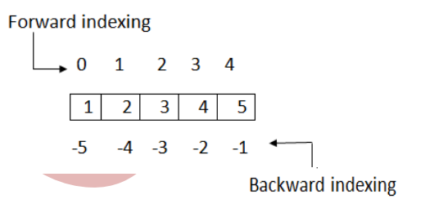

Python List Operations
Apart from creating and accessing elements from the list, Python allows us to perform various other operations on the list. Some common operations are given below:-

- Adding Python Lists
In Python, lists can be added by using the concatenation operator (+) to join two lists.

- Replicating Python Lists
Replicating means repeating, It can be performed by using '*' operator by a specific number of time.

- Slicing Python List
A subpart of a list can be retrieved on the basis of index. This subpart is known as list slice. This feature allows us to get sub-list of specified start and end index.

- Updating List
To update or change the value of particular index of a list, assign the value to that particular index of the List.

- Appending Elements to Python List

Python provides, append() method which is used to append i.e., add an element at the end of the existing elements.
- Deleting Elements from Python List
In Python, del statement can be used to delete an element from the list. It can also be used to delete all items from startIndex to endIndex.

List Built-In Methods
Python provides various Built-in functions and methods for Lists that we can apply on the list. Following are the common list functions.
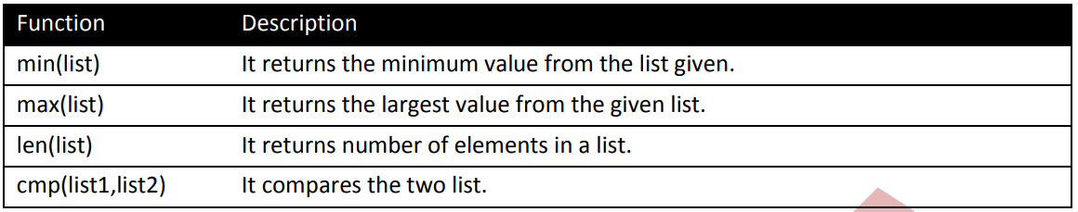

- Python List min() method
This method is used to get min value from the list.

- Python List max() method
This method is used to get max value from the list.

- Python List len() method
This method is used to get total length of list.

More Built-In List Methods
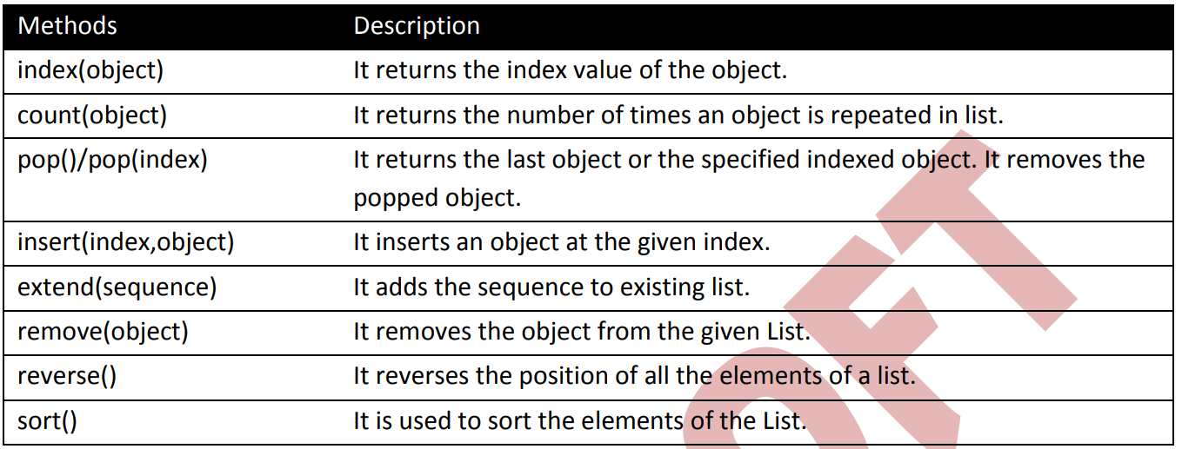

- Python List index() Method

- Python List count(object) Method

- Python List pop()/pop(int) Method

- Python List insert(index,object) Method

- Python List extend(sequence) Method
- Python List remove(object) Method
- Python List reverse() Method
- Python List sort() Method
List using Range Function

